SIMATS ENGINEERING (SAVEETHA SCHOOL OF ENGINEERING)
Department of Computer Science and Engineering
CO1 ASSESSMENT TOOL 1 – Case Study Analysis
Course Code: | CSA10 / CSA1004 | Course Title: | Software Engineering
CO Assessed: | CO1 | Assessment: | Assessment Tool 1 – Case Study Analysis
Weightage: | 20% | Total Marks: | 25
CO1 Statement: | Apply advanced methodologies and agile project management techniques to manage software projects effectively
Student Name: | NIRANJANA A | Reg. No.: | 192521370
Date: | 10/10/2026 | Duration: | 60 minutes

Code of Conduct
I Niranjana (192521370) (Name / Reg No) certify that this submission is my original work and that I have adhered to the guidelines specified for this assessment. I understand that any violation of academic integrity rules will result in disciplinary action.
Signature of the Student: _________________________
Annexure A – Case Study Analysis

CASE STUDY ANALYSIS
Smart Employee Attendance and Workforce Management Platform

1. Understand the Problem Statement
1.1 Problem Explanation
Organizations with many employees need an efficient system to manage attendance, shifts, leave requests, and employee information. Traditional attendance methods, such as registers and spreadsheets, can lead to errors, proxy attendance, and difficulties in maintaining records.
The Smart Employee Attendance and Workforce Management Platform is a software-based system designed to automate these activities. It allows employees to record attendance, view their work schedules, apply for leave, and check their attendance history. Managers can monitor employee attendance, approve leave requests, manage shifts, and generate reports.

1.2 Objectives
The main objectives of the proposed system are:
- To record employee attendance digitally.
- To manage employee shifts efficiently.
- To process employee leave requests.
- To generate accurate attendance reports.
- To identify attendance irregularities.
- To provide separate dashboards for employees and managers.
- To maintain employee attendance histories.
- To support workforce planning through management analytics.

1.3 Scope of the System
The system can be used in companies, offices, hospitals, educational institutions, and other organizations. It covers employee authentication, attendance recording, shift scheduling, leave management, report generation, and workforce analytics.
The system helps employees access their information and enables managers to monitor workforce activities. Payroll-related information can also be generated from attendance records. However, actual salary processing can be handled by a separate payroll system.

2. Identify Key Stakeholders and Challenges
2.1 Key Stakeholders
1. Employees: Employees use the system to mark attendance, view their attendance history, check shift schedules, and submit leave requests.
2. Managers and Team Leaders: They monitor employee attendance, allocate shifts, review attendance irregularities, and approve or reject leave requests according to company policies.
3. Human Resource (HR) Department: The HR department maintains employee information, manages attendance policies, monitors leave balances, and prepares attendance reports.
4. System Administrator: The administrator manages user accounts, assigns access permissions, maintains system security, and ensures the system operates properly.
5. Organization Management: Management uses reports and analytics to understand workforce availability, attendance patterns, and staffing requirements.

2.2 Major Challenges
The major challenges faced by stakeholders are:
- Incorrect attendance records due to manual entry.
- Proxy attendance, where one employee records attendance for another.
- Difficulty in managing shifts for a large number of employees.
- Delays in approving leave requests.
- Time-consuming preparation of attendance reports.
- Difficulty in identifying late arrivals and early departures.
- Security risks involving confidential employee information.
- Technical issues such as network failures and system downtime.
The proposed system aims to reduce these challenges through automation, secure authentication, centralized records, and real-time attendance visibility.

3. Analyze the Current Approach
3.1 Existing System
Many organizations use attendance registers, punch cards, spreadsheets, or separate attendance machines to record employee attendance. Shift schedules may be maintained manually, while employees submit leave requests through paper forms, emails, or messaging applications.
HR staff must collect and verify attendance information before preparing reports. This process can become difficult when the number of employees increases.

3.2 Strengths of the Existing System
- Paper registers and spreadsheets are simple to use.
- Basic attendance records can be maintained without complex software.
- Traditional attendance machines can record employee entry and exit times.
- Small organizations may find manual methods inexpensive to start with.

3.3 Limitations of the Existing System
- Manual entry can cause errors and duplicate records.
- Proxy attendance may occur if identity verification is weak.
- Preparing monthly attendance reports requires additional time.
- Managing employee shifts manually is difficult.
- Leave requests may be delayed or misplaced.
- Employee attendance history may be scattered across different records.
- Manual systems provide limited real-time visibility.
- Confidential employee information may not have adequate access controls.

3.4 Gaps to Be Addressed
The existing approach lacks centralized attendance management, efficient shift scheduling, automated report generation, and timely identification of attendance irregularities.
The proposed platform addresses these gaps by integrating attendance, shift management, leave requests, employee dashboards, and workforce analytics into one system.

4. Propose a Suitable Solution Using Software Engineering Principles
4.1 Proposed Solution
The proposed solution is a web-based Smart Employee Attendance and Workforce Management Platform. Employees and authorized staff can log in using secure credentials and access features according to their roles.
Employees can record attendance, view shift schedules, check attendance history, and submit leave requests. Managers can manage shifts, review attendance records, and process leave requests. HR staff can maintain employee information and generate reports.
The system stores information in a centralized database and provides updated attendance information to authorized users.

4.2 Major Functional Modules
Module 1: Employee Authentication and Management
This module allows employees, managers, HR staff, and administrators to log in securely. It manages employee profiles and provides access according to user roles.
Module 2: Digital Attendance Management
This module records employee check-in and check-out times. It maintains daily attendance records and helps identify late arrivals, early departures, missing check-outs, and other irregularities.
Module 3: Shift Management
This module allows managers to create work shifts, assign shifts to employees, and update schedules when required. Employees can view their assigned shifts through their dashboards.
Module 4: Leave Management
Employees can submit leave requests through the platform. Managers or authorized HR staff can approve or reject requests. The system maintains leave records and request statuses.
Module 5: Reports and Workforce Analytics
This module generates daily, weekly, and monthly attendance reports. It summarizes attendance patterns, absences, late arrivals, and workforce availability to support management decisions.
Module 6: Employee Dashboard
The dashboard provides employees with access to their attendance records, shift schedules, leave status, and relevant notifications.

4.3 Functional Requirements
Functional requirements describe what the system must do.
- The system must allow authorized users to log in securely.
- It must record employee check-in and check-out times.
- It must maintain employee profiles and attendance histories.
- It must allow managers to assign and modify shifts.
- It must allow employees to submit leave requests.
- It must allow authorized staff to approve or reject leave requests.
- It must identify attendance irregularities based on defined rules.
- It must generate attendance reports.
- It must provide dashboards for employees and management.
- It must restrict access to information according to user roles.

4.4 Non-Functional Requirements
Non-functional requirements describe how well the system should operate.
- Security: Employee information must be protected through secure authentication and role-based access control.
- Reliability: The system should record and retrieve attendance information accurately.
- Usability: The interface should be simple and easy to understand.
- Scalability: The system should support an increasing number of employees.
- Performance: Attendance records and reports should be available within a reasonable time.
- Maintainability: The software should be easy to update, test, and maintain.
- Availability: The system should be accessible whenever required, subject to network and service availability.

4.5 Application of Software Engineering Principles
Modularity: The system is divided into separate modules for attendance, shifts, leave, authentication, and reporting. Each module can be developed and tested independently.
Scalability: The system can be designed to support more employees and additional organizational branches as the organization grows.
Maintainability: Clear code structure, documentation, and modular design make it easier to correct errors and introduce new features.
Reliability: Input validation, database constraints, regular backups, and testing help maintain accurate attendance records.
Usability: Simple dashboards and clear navigation make the system convenient for employees and managers.
Security: Secure login, role-based permissions, encrypted communication, and controlled access help protect employee information.

5. Justify the Chosen Methodology/Framework
5.1 Selected Methodology: Agile with Scrum
Agile with Scrum is selected as the software development methodology for this project. Scrum is an Agile framework in which a project is developed through short, iterative development cycles called sprints.
Each sprint focuses on completing and testing a selected set of features. The development team reviews progress regularly and improves the product based on feedback.

5.2 Why Scrum Is Suitable
Scrum is suitable for this project for the following reasons:
- Incremental Development: The system can be developed module by module, starting with authentication and attendance recording.
- Continuous Feedback: Employees, managers, and HR staff can provide feedback during development.
- Early Testing: Each completed module can be tested before the next set of features is added.
- Flexibility: Changes in attendance policies or shift requirements can be incorporated into later sprints.
- Team Collaboration: Developers can divide the work among different modules and coordinate their progress.
- Risk Reduction: Regular reviews and testing help identify problems at an early stage.

5.3 Implementation Using Scrum
The project can be divided into the following sprints:
- Sprint 1: Requirements gathering, project planning, and user interface design.
- Sprint 2: Employee authentication and profile management.
- Sprint 3: Digital attendance recording and attendance history.
- Sprint 4: Shift scheduling and leave management.
- Sprint 5: Reports, dashboards, and workforce analytics.
- Sprint 6: System testing, security checks, bug fixing, and final deployment.
At the end of each sprint, the team reviews the completed features and identifies improvements for the next sprint.

5.4 Support for Maintenance
After deployment, Scrum supports continuous improvement through feedback, bug fixes, and additional development cycles. New features, such as mobile access or integration with payroll software, can be added in future sprints.

6. Discuss Expected Outcomes and Limitations
6.1 Expected Outcomes
The proposed system is expected to provide the following benefits:
- Accurate Attendance Records: Digital recording reduces manual entry errors.
- Reduced Administrative Effort: Automation reduces the time HR staff spend maintaining records and preparing reports.
- Improved Workforce Visibility: Managers can access updated attendance information.
- Efficient Shift Management: Centralized scheduling makes it easier to allocate and modify shifts.
- Faster Report Generation: Daily, weekly, and monthly reports can be generated more efficiently.
- Better Leave Management: Employees can submit requests online and track their status.
- Identification of Irregularities: The system can flag late arrivals, missing check-outs, and other rule-based exceptions.
- Better Workforce Planning: Attendance reports help management understand staffing patterns and workforce availability.

6.2 Potential Risks and Limitations
- Technical Failures: Network problems or server failures may temporarily prevent access to the system.
- Data Security Risks: Employee information may be exposed if security controls are inadequate.
- Incorrect Data Entry: Errors can still occur if incorrect information is entered or attendance records are not properly verified.
- Implementation Cost: Developing, deploying, and maintaining the platform requires time and resources.
- Employee Training: Some employees may need training to use the system effectively.
- Device and Network Dependency: Online attendance recording may be difficult when employees do not have access to suitable devices or a reliable network.
- False Alerts: Attendance irregularities identified by the system may require human verification before action is taken.

6.3 Future Enhancements
The platform can be improved in the future by introducing:
- Mobile application support for convenient attendance access.
- GPS-based attendance for authorized field employees.
- Optional biometric verification to strengthen identity checks.
- Integration with payroll software to simplify payroll preparation.
- Automated notifications for shifts, leave approvals, and attendance exceptions.
- AI-based workforce analytics to identify attendance patterns and support staffing decisions.
- Cloud deployment to improve accessibility and scalability.

Conclusion
The Smart Employee Attendance and Workforce Management Platform provides a centralized and efficient approach to managing employee attendance, shifts, leave requests, and workforce information. It reduces dependence on manual processes, improves record accuracy, and helps organizations make better workforce decisions.
Using software engineering principles such as modularity, security, reliability, scalability, and maintainability makes the system easier to develop and manage. The Agile Scrum methodology supports incremental development, continuous feedback, and regular testing. Therefore, the proposed platform can improve workforce visibility and reduce administrative effort in organizations.
IMPLEMENTATION:
Smart Employee Attendance and Workforce Management
KANBAN BOARD
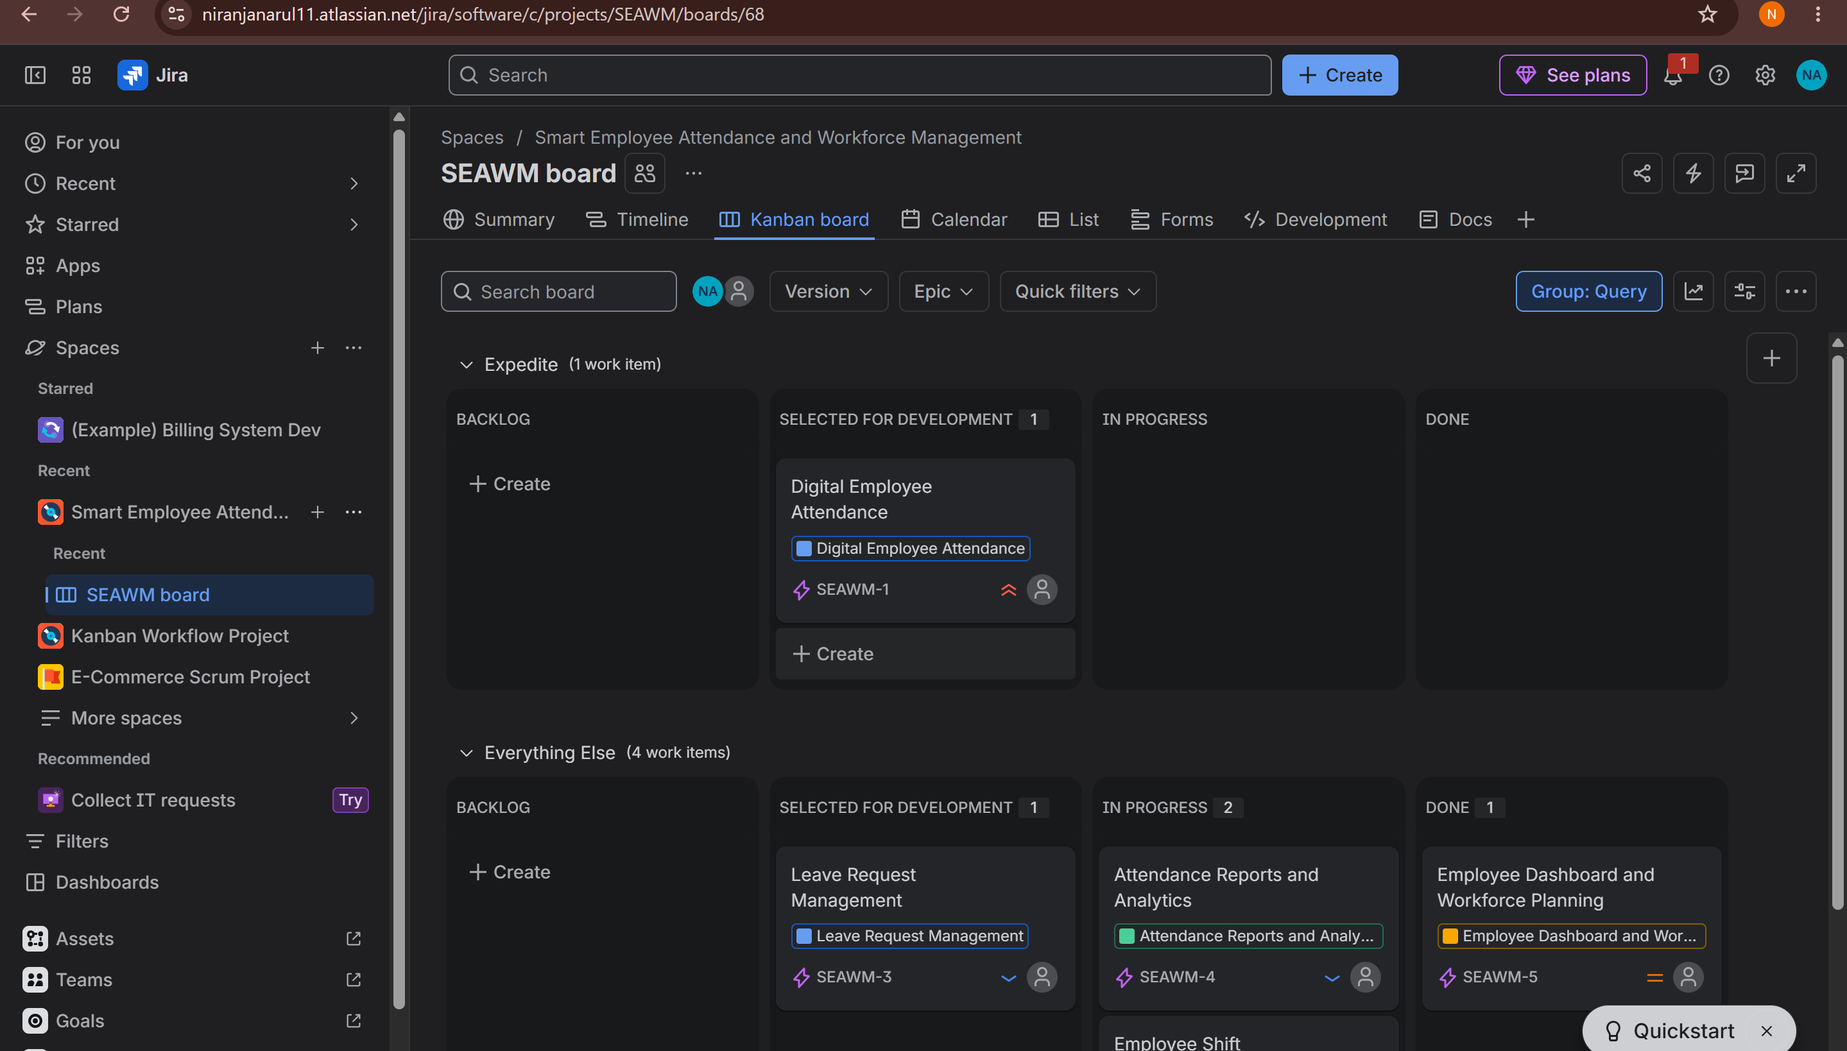

OUTPUT
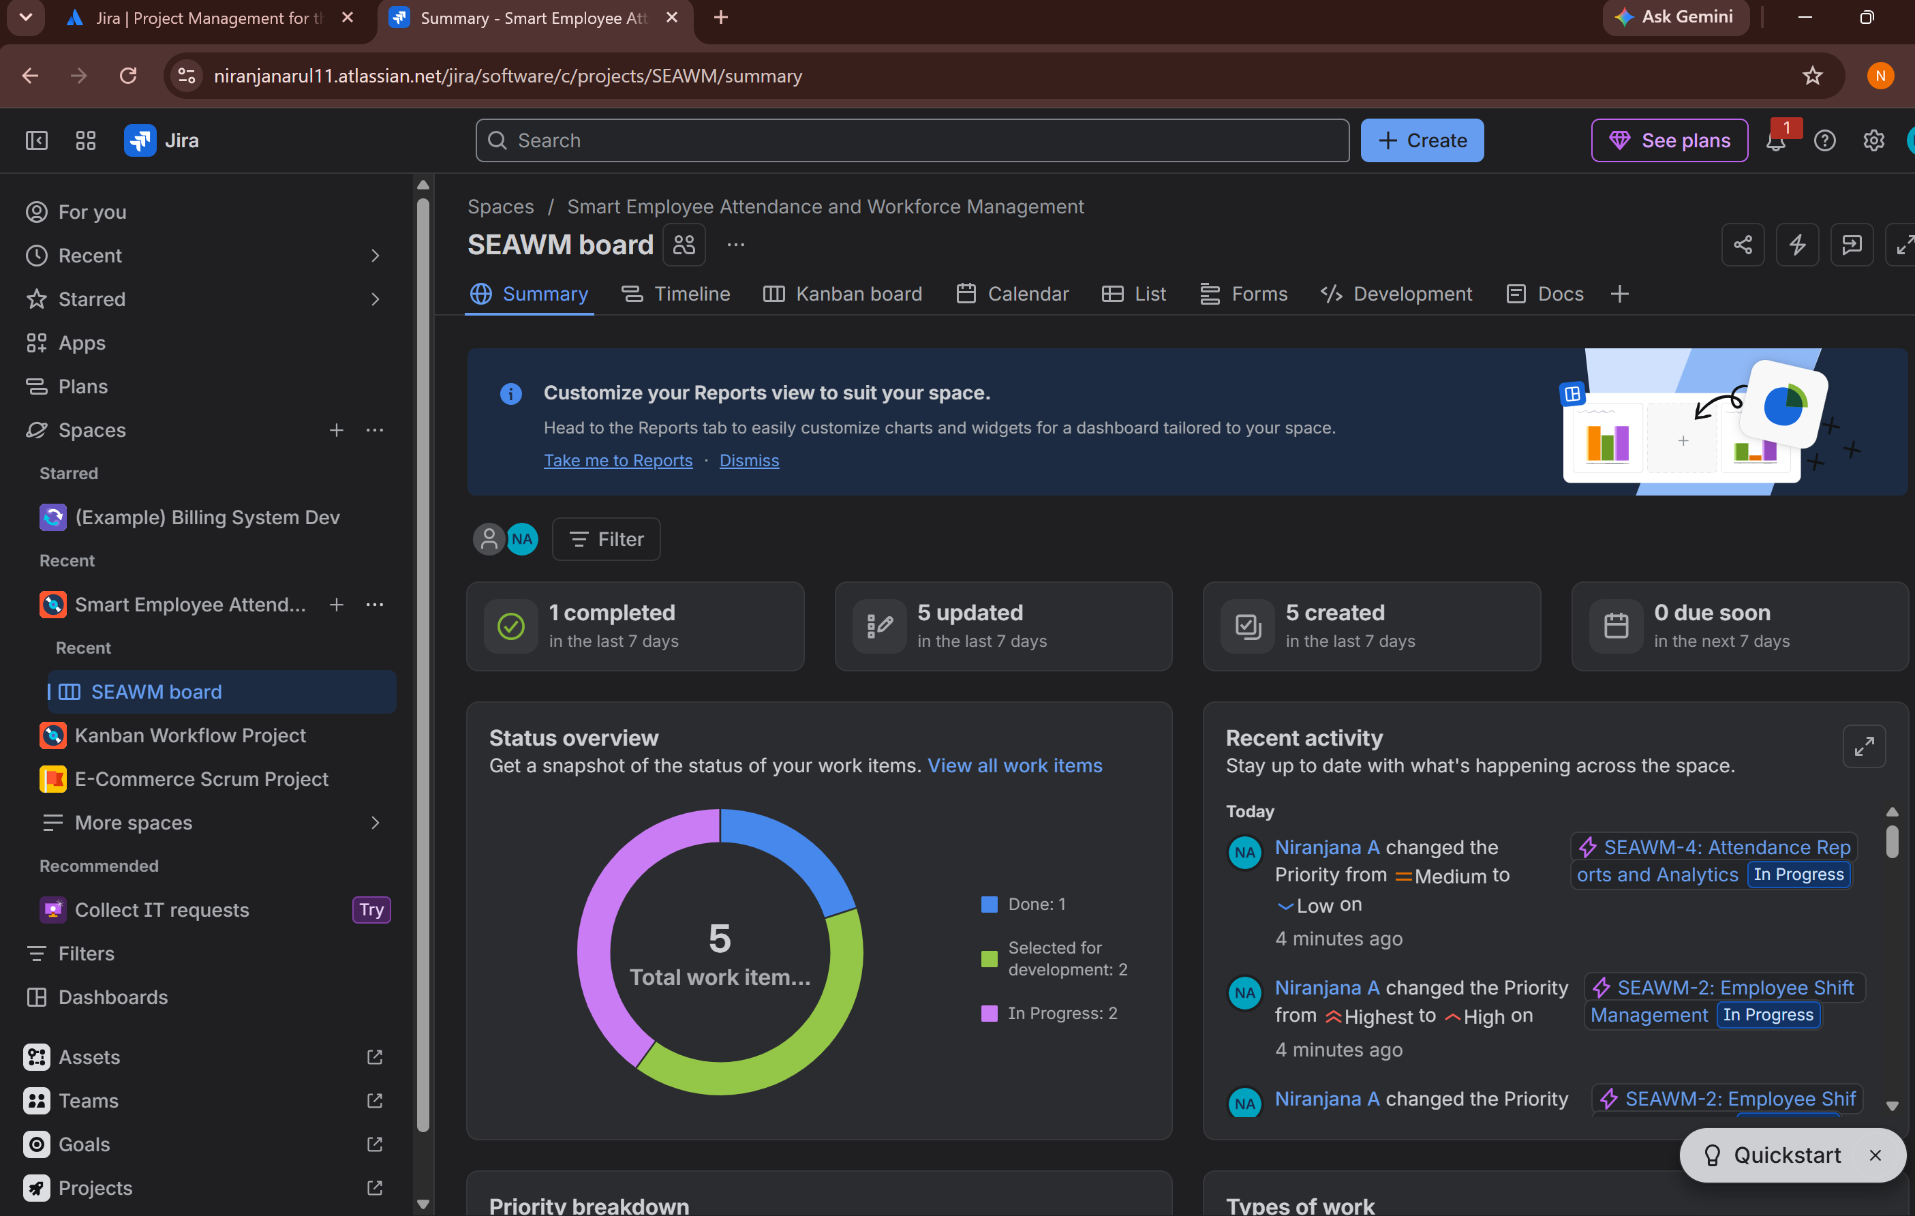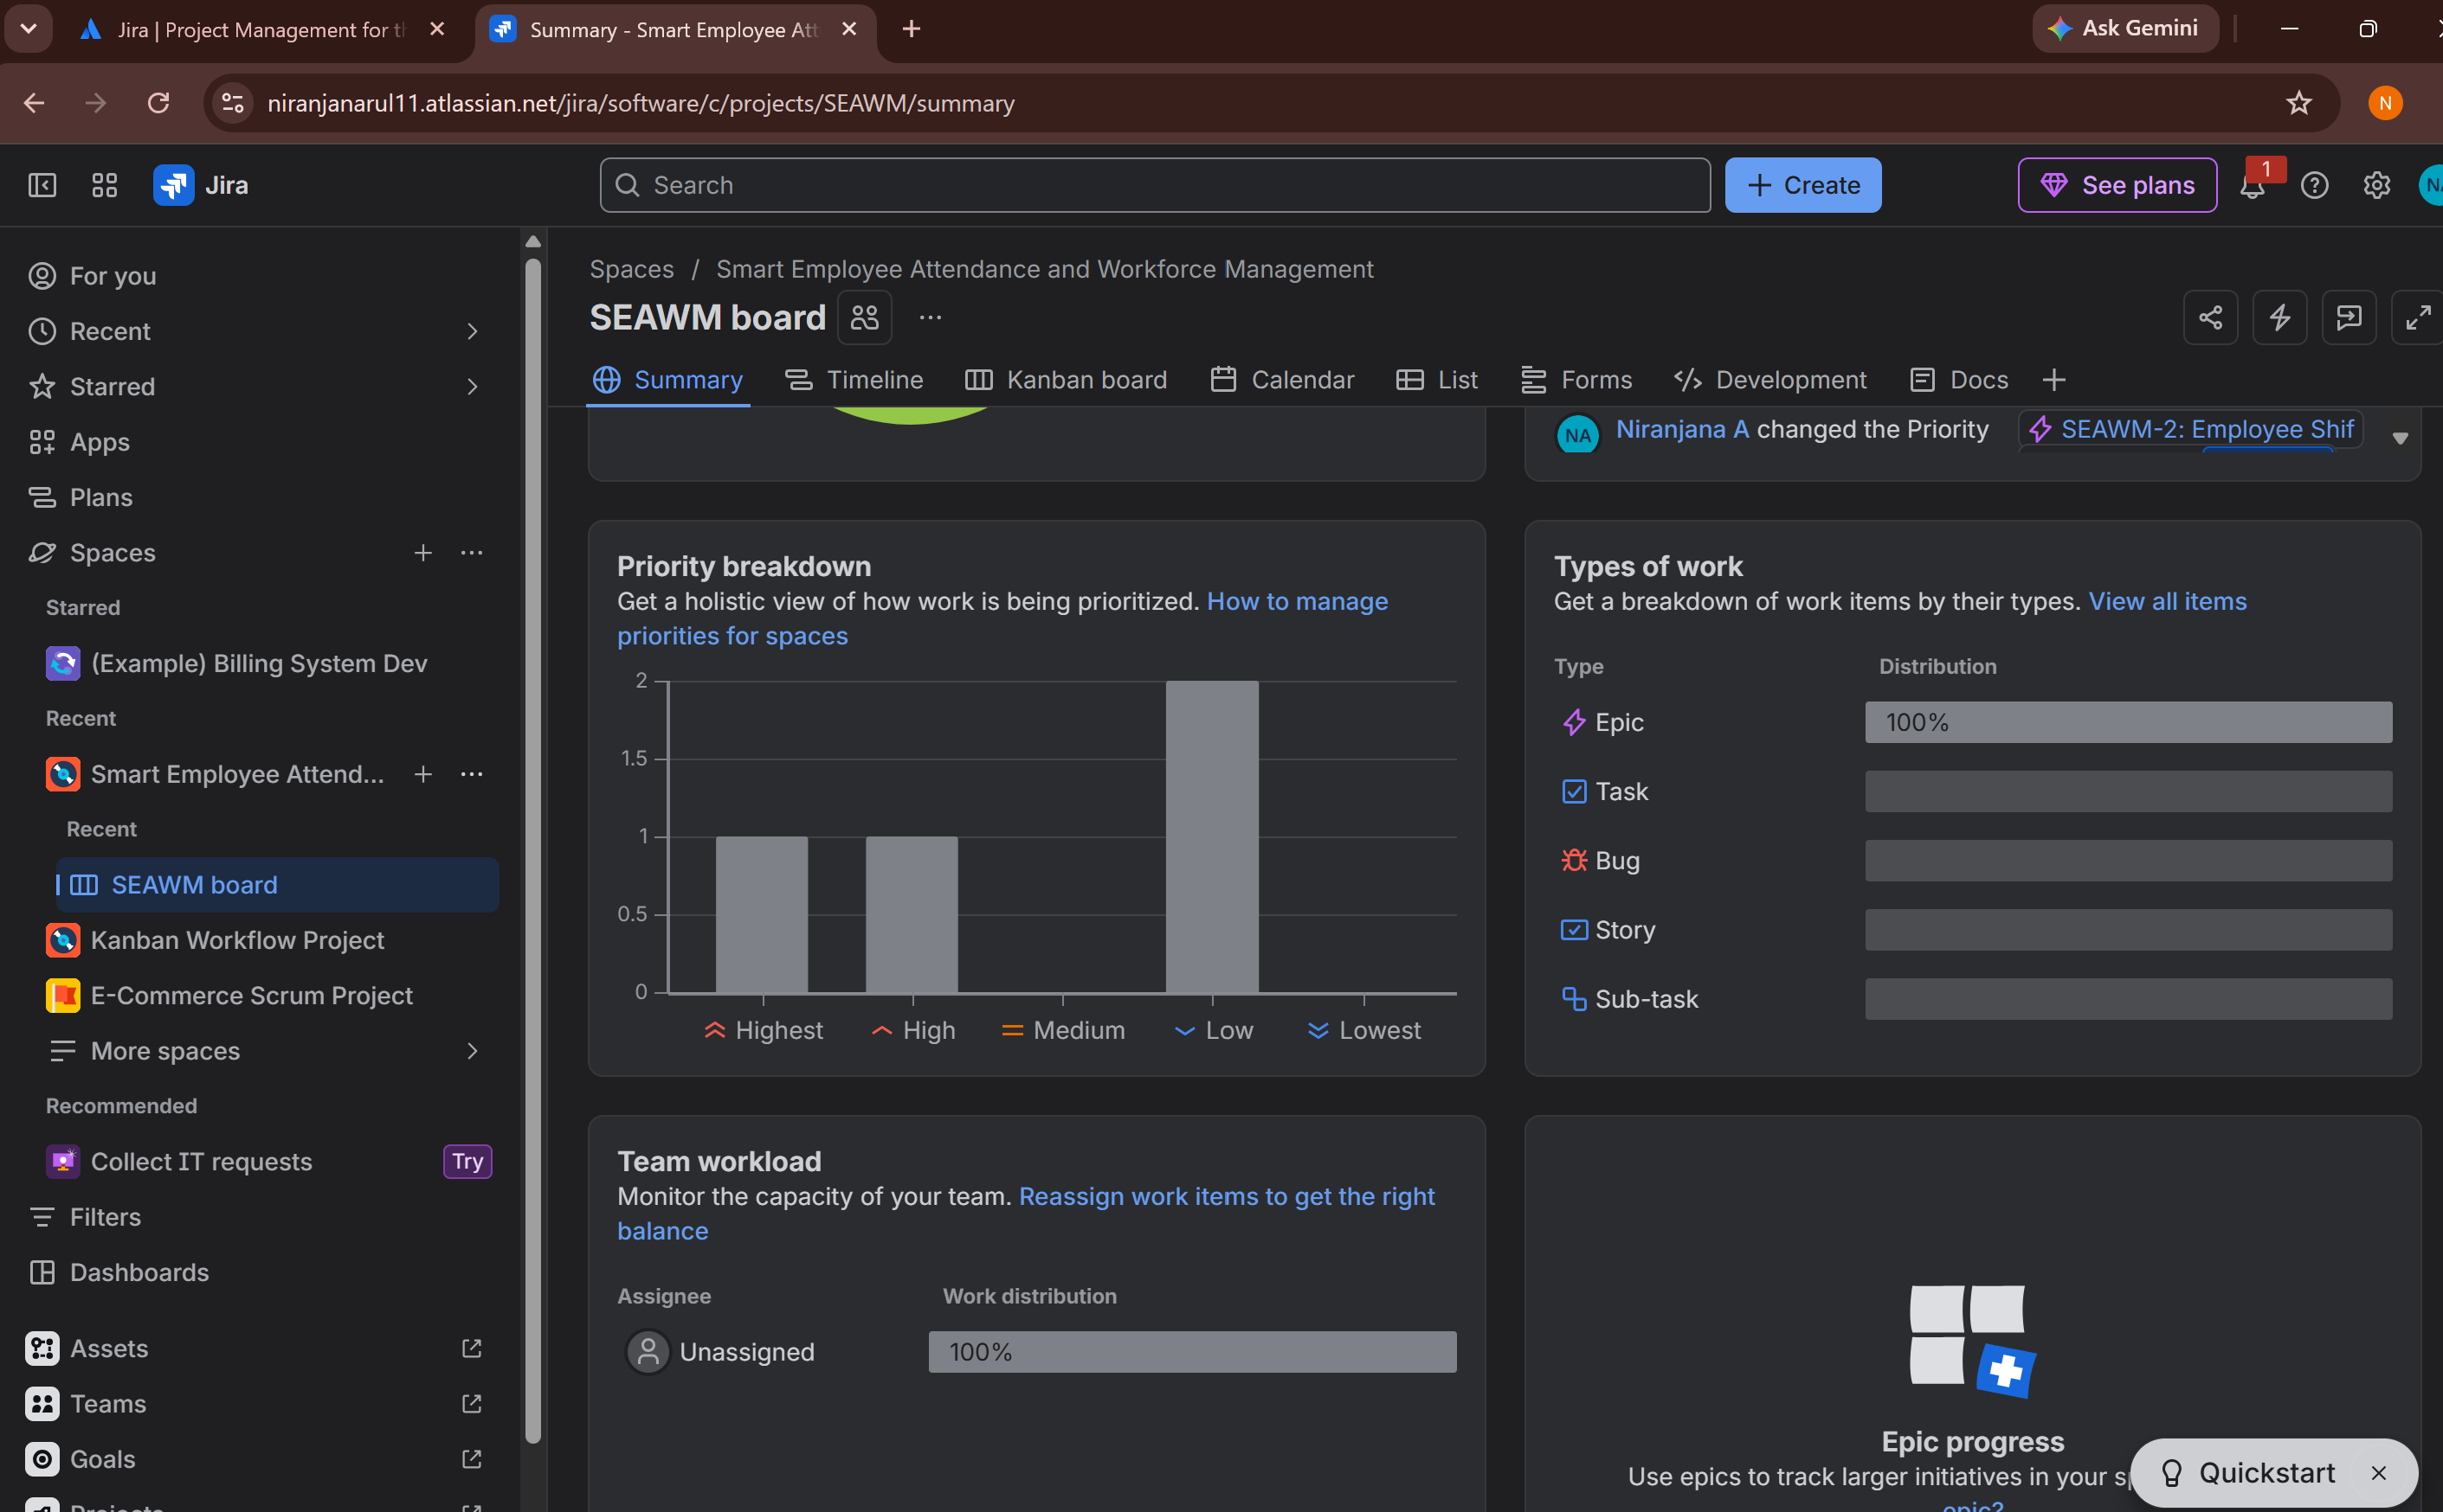

Rubrics for Calculation
Criteria | Excellent (5 Marks) | Good (3 Marks) | Satisfactory (2 Marks) | Needs Improvement (1 Mark)
Problem Understanding (30%) | Clearly explains the problem, objectives, and scope with complete understanding. | Explains the problem with minor omissions. | Basic understanding with limited explanation. | Poor understanding; objectives and scope are unclear or missing.
Stakeholder & Challenge Analysis (25%) | Identifies all stakeholders, their roles, and challenges with clear analysis. | Identifies most stakeholders and challenges with adequate analysis. | Identifies only a few stakeholders or challenges. | Stakeholders and system analysis are incomplete or inaccurate.
Current System Analysis (20%) | Thoroughly analyzes the existing system, strengths, weaknesses, and identifies all gaps. | Good analysis with most strengths and weaknesses identified. | Limited analysis with partial identification of issues. | Proposed solution is unclear or inappropriate; requirements are largely missing.
Proposed Software Solution & Software Engineering Principles (15%) | Proposes an innovative, feasible solution applying appropriate software engineering principles (modularity, scalability, maintainability, security, etc.). | Suitable solution with good application of software engineering principles. | Basic solution with limited application of software engineering principles. | Methodology is inappropriate, poorly justified, or not discussed.
Methodology/ Framework Justification (10%) | Selects the most suitable SDLC/model/framework and provides strong technical justification. | Suitable methodology selected with adequate justification. | Methodology selected but justification is weak. | Outcomes, limitations, or future enhancements are missing; report lacks organization and clarity.

Criteria | Mark
Problem Understanding (30%) | /5
Stakeholder & Challenge Analysis (25%) | /5
Current System Analysis (20%) | /5
Proposed Software Solution & Software Engineering Principles (15%) | /5
Methodology/ Framework Justification (10%) | /5
TOTAL | /25

